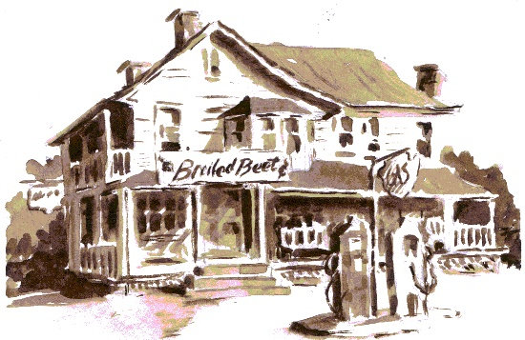 | Welcome to Chelm’s Pond
Day, Date, Time, Place
Welcome to Chelm’s Pond, where the ridiculous stories of Chelm meet the preposterous tall tales of the Adirondacks.
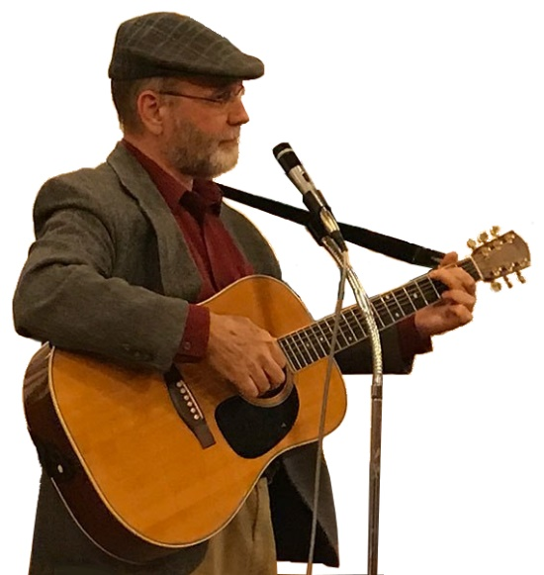
Sandy Schuman is a storyteller, musician, and educator. He tells stories about songs and song-writers, personal adventures, historical sagas, folk tales, and stories in the Jewish storytelling tradition.

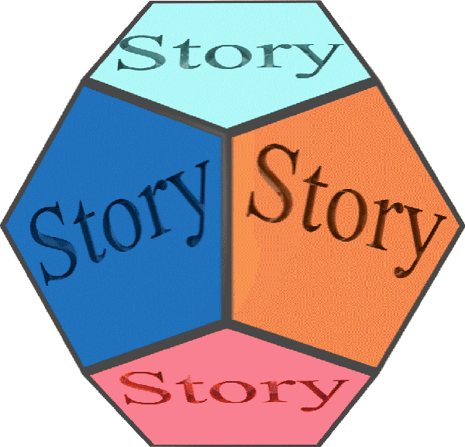  www.tothestory.com | Venue logo | Sponsor logo

