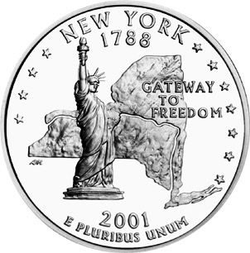 | New York Tales:  Tall & True  History and Folklore of the Empire State
Day, Date, Time, Place
Some of New York State’s folklore is truly unbelievable.
Some of its history is even more so.
Sandy Schuman is a storyteller, musician, and educator. He tells stories about songs and song-writers, personal adventures, historical sagas, folk tales, and stories in the Jewish storytelling tradition.

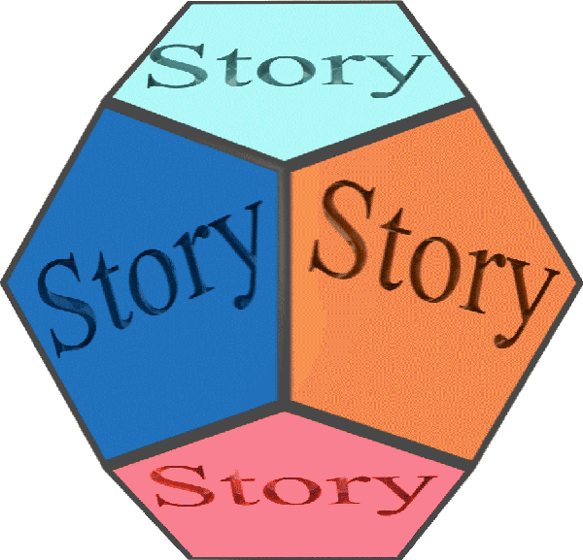  www.tothestory.com | Venue logo | Sponsor logo

