My Father  was a  Storyteller | 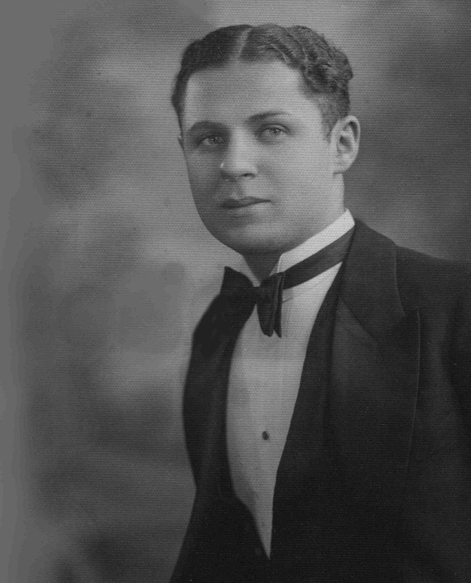
Day, Date, Time, Place
“My father gave me a quarter and I had to decide how to spend it." So begins this personal and historical saga that stretches from the help wanted ads of the Philadelphia Inquirer to the front page of the New York Times, from the pleasant beaches of Atlantic City to the hectic skyscrapers of Manhattan, and from my father’s longed-for saxophone to my sister’s studio-upright piano.
Sandy Schuman is a storyteller, musician, and educator. He tells stories about songs and song-writers, personal adventures, historical sagas, folk tales, and stories in the Jewish storytelling tradition.
Venue logo | Sponsor logo
Sandy Schuman
www.tothestory.com

