Jewish Stories Every Person Should Know
Day, Date, Time, Place
A Rabbi, a Prophet, and a King Walk into a Bar; If Not Even Higher; The Angel’s Question – and more stories, old and new, that reveal Jewish humor, tradition, and values.
Sandy Schuman is a storyteller, musician, and educator. He tells stories about songs and song-writers, personal adventures, historical sagas, folk tales, and stories in the Jewish storytelling tradition.

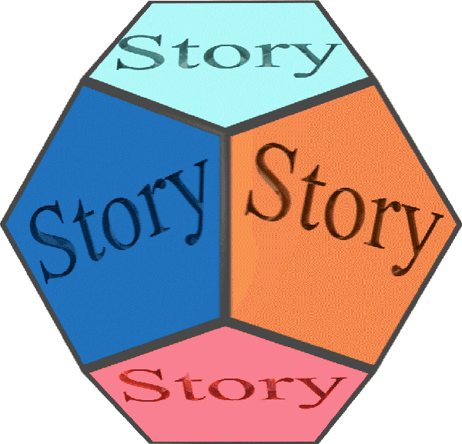  www.tothestory.com | Venue logo | Sponsor logo

