Song
of the
Century
Familiar Songs and their Unfamiliar Stories
Day, Date, Time, Place

Learn how some of the best-known American songs came to be written. This program features songs from the Great American Songbook and stories about the people who wrote them. Sing along, if you like!
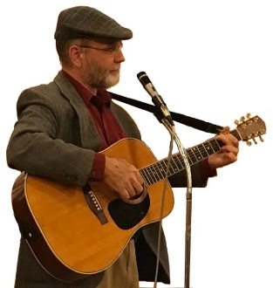
Sandy Schuman is a storyteller, musician, and educator. He tells stories about songs and song-writers, personal adventures, historical sagas, folk tales, and stories in the Jewish storytelling tradition.

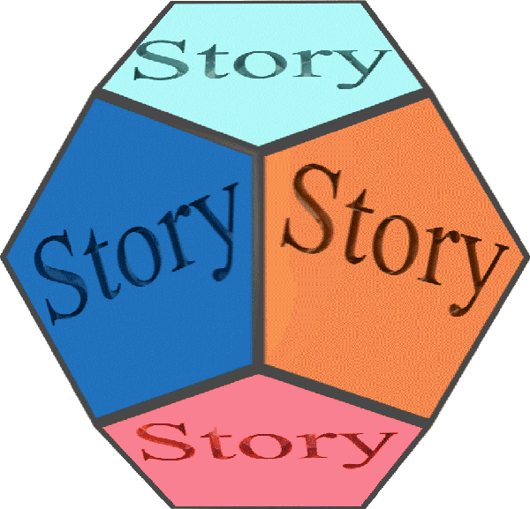  www.tothestory.com | Venue logo | Sponsor logo

